# US Census Bureau - Project Overview for Agile Workshop

## I. Background

The Department of Commerce has a Strategic Plan with the theme of “America is Open for Business.” Two key focus areas within this strategy plan areas are (1) innovation, and (2) data.

Resource: [PDF of Department of Commerce Strategic Plan](http://www.commerce.gov/sites/default/files/documents/2014/march/doc_fy2014-2018_strategic_plan.pdf)

## II. Census Project – “Open for Business” Web Application

Resource: [“Open for Business” Web Application](http://wdccivweb.esri.com/open-for-business/)

The Census is working on is a web application called “Open for Business” that is intended to help entrepreneurs use government data (and possibly 3rd party data like Yelp) to figure out where best to open up a business.

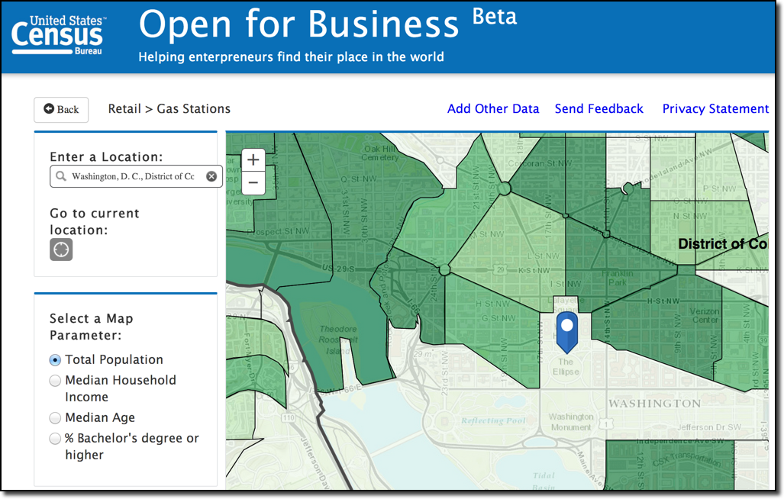

*How does this fit into the Dept of Commerce Strategic Plan?* Census, along with other agencies within the Dept of Commerce such as NOAA, are teaming up to tackle the innovation and data pillars. “Open for Business” web application is one example project.

## III. Suggested Activities for Agile Workshop

***“Must Have” deliverable from workshop - General Usability Feedback***

* Provide Usability Testing for “Open for Business” Web application that the engineering team can use to improve current version of the product

***Prototype #1 – Business Report***

* Deliver a prototype for the “Business Report” that end-users (entrepreneurs) may use to start their own business, or apply for a small business loan.

***Prototype #2 – Open Data***

* Determine how best to make the product more “open” by providing developers with API information.

***Prototype #3 - Combine data results with 3rd party data from Yelp***

* Build a prototype that combines the government data with a 3rd party source of information such as Yelp, to understand competitors in the space.